# DR project

**Prediction of Renal Replacement Therapy application in Heart Failure Patients with a poor response to diuretics**

**Cohort:** Diuretic resist patients exclude ESRD, DR was defined by diuretic drug use (over 2 unit) and Echo report (LVEF is severe).

**Primary Outcome:** RRT

### **Preprocess – missing values**

* + ) Several patients may have wrong weight values, since they are no-RRT patients, remove them entirely.
  + ) cvp have many missing values ( > 863/1271), so do urine_acid, bnp and base excess(this one exclude admission), better remove them before analysis.
  + ) And the third timestamp (get better date) have about a half missing data, for more then 500 no-rrt patients can’t find a urine increase time according to the definition. This may cause bias, but analysis below will still include these variables.

**Analysis:**

### **Baseline characteristics, stratified by rrt.**

|  |  |  |  |
| --- | --- | --- | --- |
|  | Non RRT (n= 1124 ) | RRT (n= 93 ) | p-value |
| "age (mean (sd))" | 70.80 (13.81) | 67.78 (13.68) | 0.042 |
| "gender = 1 (%)" | 707 (62.9) | 62 (66.7) | 0.541 |
| "height (mean (sd))" | 169.60 (10.58) | 169.61 (10.60) | 0.994 |
| "weight_adm (mean (sd))" | 84.05 (24.00) | 85.58 (28.86) | 0.577 |
| "bmi (mean (sd))" | 29.11 (7.56) | 29.55 (9.39) | 0.617 |
| "bbr = 1 (%)" | 1018 (90.6) | 75 (80.6) | 0.004 |
| "inotropes_vasopressor = 1 (%)" | 850 (75.6) | 73 (78.5) | 0.62 |
| "acei = 1 (%)" | 497 (44.2) | 13 (14.0) | <0.001 |
| "mra = 1 (%)" | 218 (19.4) | 5 ( 5.4) | 0.001 |
| "vasodilator = 1 (%)" | 525 (46.7) | 41 (44.1) | 0.705 |
| "ischemic_heart_disease = 1 (%)" | 758 (67.4) | 52 (55.9) | 0.032 |
| "cardiomyopathies = 1 (%)" | 274 (24.4) | 13 (14.0) | 0.032 |
| "valvular_disease = 1 (%)" | 182 (16.2) | 12 (12.9) | 0.493 |
| "atrial_fibrilation = 1 (%)" | 585 (52.0) | 40 (43.0) | 0.117 |
| "hyperlipidemia = 1 (%)" | 392 (34.9) | 13 (14.0) | <0.001 |
| "hypertension = 1 (%)" | 268 (23.8) | 33 (35.5) | 0.018 |
| "diabetes = 1 (%)" | 471 (41.9) | 33 (35.5) | 0.272 |
| "sleep_disordered_breathing = 1 (%)" | 87 ( 7.7) | 2 ( 2.2) | 0.075 |
| "renal_failure = 1 (%)" | 332 (29.5) | 43 (46.2) | 0.001 |
| "anemia = 1 (%)" | 402 (35.8) | 30 (32.3) | 0.571 |
| "infection = 1 (%)" | 652 (58.0) | 72 (77.4) | <0.001 |
| "alcohol_abuse = 1 (%)" | 53 ( 4.7) | 3 ( 3.2) | 0.688 |
| "hr_adm (mean (sd))" | 91.35 (19.53) | 90.88 (20.51) | 0.826 |
| "sbp_adm (mean (sd))" | 114.63 (22.25) | 113.59 (25.10) | 0.667 |
| "dbp_adm (mean (sd))" | 62.56 (17.05) | 59.43 (14.46) | 0.086 |
| "spo2_adm (mean (sd))" | 89.99 (7.11) | 94.86 (9.98) | <0.001 |
| "tem_adm (mean (sd))" | 36.33 (2.30) | 35.99 (3.91) | 0.196 |
| "gfr_adm (mean (sd))" | 51.33 (26.97) | 32.99 (25.20) | <0.001 |
| "base_excess_adm (mean (sd))" | -0.38 (5.62) | -1.78 (5.56) | 0.026 |
| "hco3_adm (mean (sd))" | 24.54 (5.09) | 22.52 (5.67) | <0.001 |
| "ph_adm (mean (sd))" | 7.38 (0.10) | 7.36 (0.10) | 0.258 |
| "hemoglobin_adm (mean (sd))" | 11.24 (2.01) | 10.38 (1.81) | <0.001 |
| "albumin_adm (mean (sd))" | 3.20 (0.60) | 2.98 (0.62) | 0.001 |
| "potassium_adm (mean (sd))" | 4.31 (0.76) | 4.63 (1.03) | <0.001 |
| "sodium_adm (mean (sd))" | 137.59 (5.13) | 137.37 (4.27) | 0.679 |
| "creatinine_adm (mean (sd))" | 1.61 (0.95) | 2.72 (1.71) | <0.001 |
| "bun_adm (mean (sd))" | 38.40 (24.74) | 58.08 (32.67) | <0.001 |

### **Characteristics of fluid value and outcomes**

|  |  |  |  |
| --- | --- | --- | --- |
|  | Non RRT (n= 1124 ) | RRT (n= 93 ) | p-value |
| "los_hos (mean (sd))" | 365.03 (293.35) | 675.44 (527.69) | <0.001 |
| "los_icu (mean (sd))" | 207.88 (216.71) | 465.47 (421.29) | <0.001 |
| "hospital_expire_flag = 1 (%)" | 210 (18.7) | 37 (39.8) | <0.001 |
| "add_drug_therapy = 1 (%)" | 524 (46.6) | 37 (39.8) | 0.245 |
| "change_drug_therapy = 1 (%)" | 161 (14.3) | 8 ( 8.6) | 0.168 |
| "fluid_overload_to_rrt (mean (sd))" | 3817.32 (11761.61) | 9117.04 (12311.12) | <0.001 |
| "daily_fluid_overload_to_rrt (mean (sd))" | 842.78 (2721.75) | 1976.48 (4131.94) | <0.001 |
| "urine_output_to_rrt (mean (sd))" | 5051.15 (7145.66) | 10612.53 (18342.06) | <0.001 |
| "daily_uo_to_rrt (mean (sd))" | 1636.74 (1298.75) | 974.25 (884.61) | <0.001 |
| "total_input_to_discharge (mean (sd))" | 27478.78 (39426.81) | 49305.14 (42549.91) | <0.001 |
| "total_output_to_discharge (mean (sd))" | 19813.67 (22669.53) | 38585.34 (35196.25) | <0.001 |
| "fluid_overload_to_dis (mean (sd))" | 7791.45 (29412.27) | 10719.80 (20891.41) | 0.354 |
| "urine_output_to_dis (mean (sd))" | 17864.05 (20817.85) | 17497.71 (23006.66) | 0.874 |

* 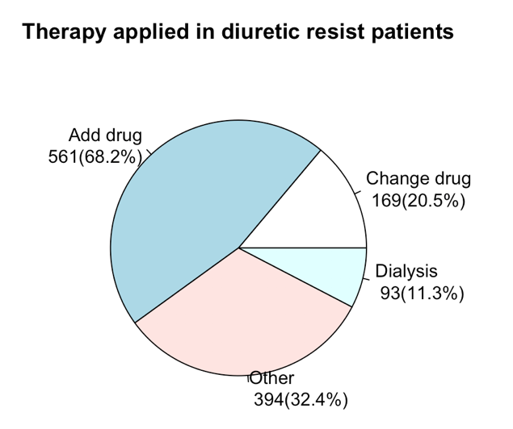**Data visualization**

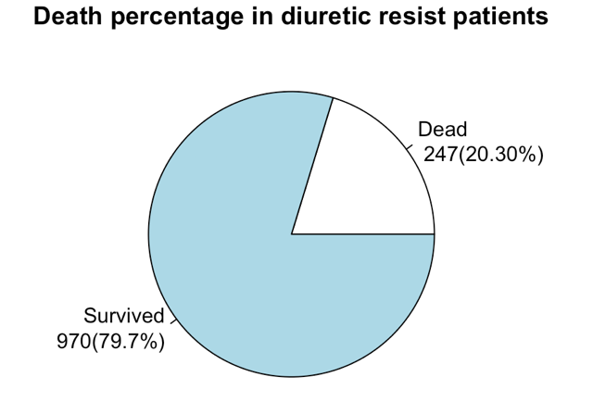

* **Use logistic regression to analyze**

Use lasso regression to select variables, and use step regression to eliminate collinearity.

**Model variables:**

Outcome variable: rrt

Exposure: gender + los_hos + los_icu + add_drug_therapy + weight_adm + acei + mra + atrial_fibrilation + hyperlipidemia + renal_failure + nosocomial_hypoproteinemia + nosocomial_anemia + nosocomial_hyponatremia + urine_output_to_rrt + daily_uo_to_rrt + total_output_to_discharge + fluid_overload_to_dis + urine_output_to_dis + hr_therapy + sbp_therapy + bun_dr + potassium_therapy

Apply lasso regression to select variables for linear regression, and use step regression to eliminate collinearity.

Result:

|  |  |  |
| --- | --- | --- |
|  | OR (95%CI) | p value |
| (Intercept) | 0.00046 ( 1e-05 , 0.02206 ) | 0.00015 |
| gender1 | 1.50195 ( 0.71999 , 3.2285 ) | 0.28555 |
| los_hos | 1.00011 ( 0.99873 , 1.00131 ) | 0.86655 |
| los_icu | 1.00323 ( 1.00063 , 1.00604 ) | 0.01805 |
| add_drug_therapy1 | 0.46974 ( 0.22788 , 0.93907 ) | 0.03565 |
| weight_adm | 1.0136 ( 0.99781 , 1.02906 ) | 0.08436 |
| acei1 | 0.17854 ( 0.06749 , 0.418 ) | 0.00019 |
| mra1 | 0.3753 ( 0.0956 , 1.17543 ) | 0.1206 |
| atrial_fibrilation1 | 0.4408 ( 0.21546 , 0.87101 ) | 0.02082 |
| hyperlipidemia1 | 0.22385 ( 0.07753 , 0.56368 ) | 0.00282 |
| renal_failure1 | 4.03515 ( 1.94925 , 8.6042 ) | 0.00021 |
| nosocomial_hypoproteinemia1 | 3.07193 ( 1.35945 , 7.1287 ) | 0.00767 |
| nosocomial_anemia1 | 2.71333 ( 1.17498 , 6.41745 ) | 0.02068 |
| nosocomial_hyponatremia1 | 3.18754 ( 1.45113 , 7.20037 ) | 0.00438 |
| urine_output_to_rrt | 1.00007 ( 1.00003 , 1.00012 ) | 0.00063 |
| daily_uo_to_rrt | 0.99943 ( 0.99892 , 0.99988 ) | 0.02064 |
| total_output_to_discharge | 1.00009 ( 1.00005 , 1.00012 ) | <0.0001 |
| fluid_overload_to_dis | 0.99998 ( 0.99996 , 0.99999 ) | 0.00364 |
| urine_output_to_dis | 0.99985 ( 0.9998 , 0.99989 ) | <0.0001 |
| hr_therapy | 0.98366 ( 0.96239 , 1.00458 ) | 0.13141 |
| sbp_therapy | 1.01929 ( 1.00239 , 1.03678 ) | 0.02596 |
| bun_dr | 1.00761 ( 0.99442 , 1.02047 ) | 0.24812 |
| potassium_therapy | 1.66856 ( 0.94826 , 2.92866 ) | 0.07486 |